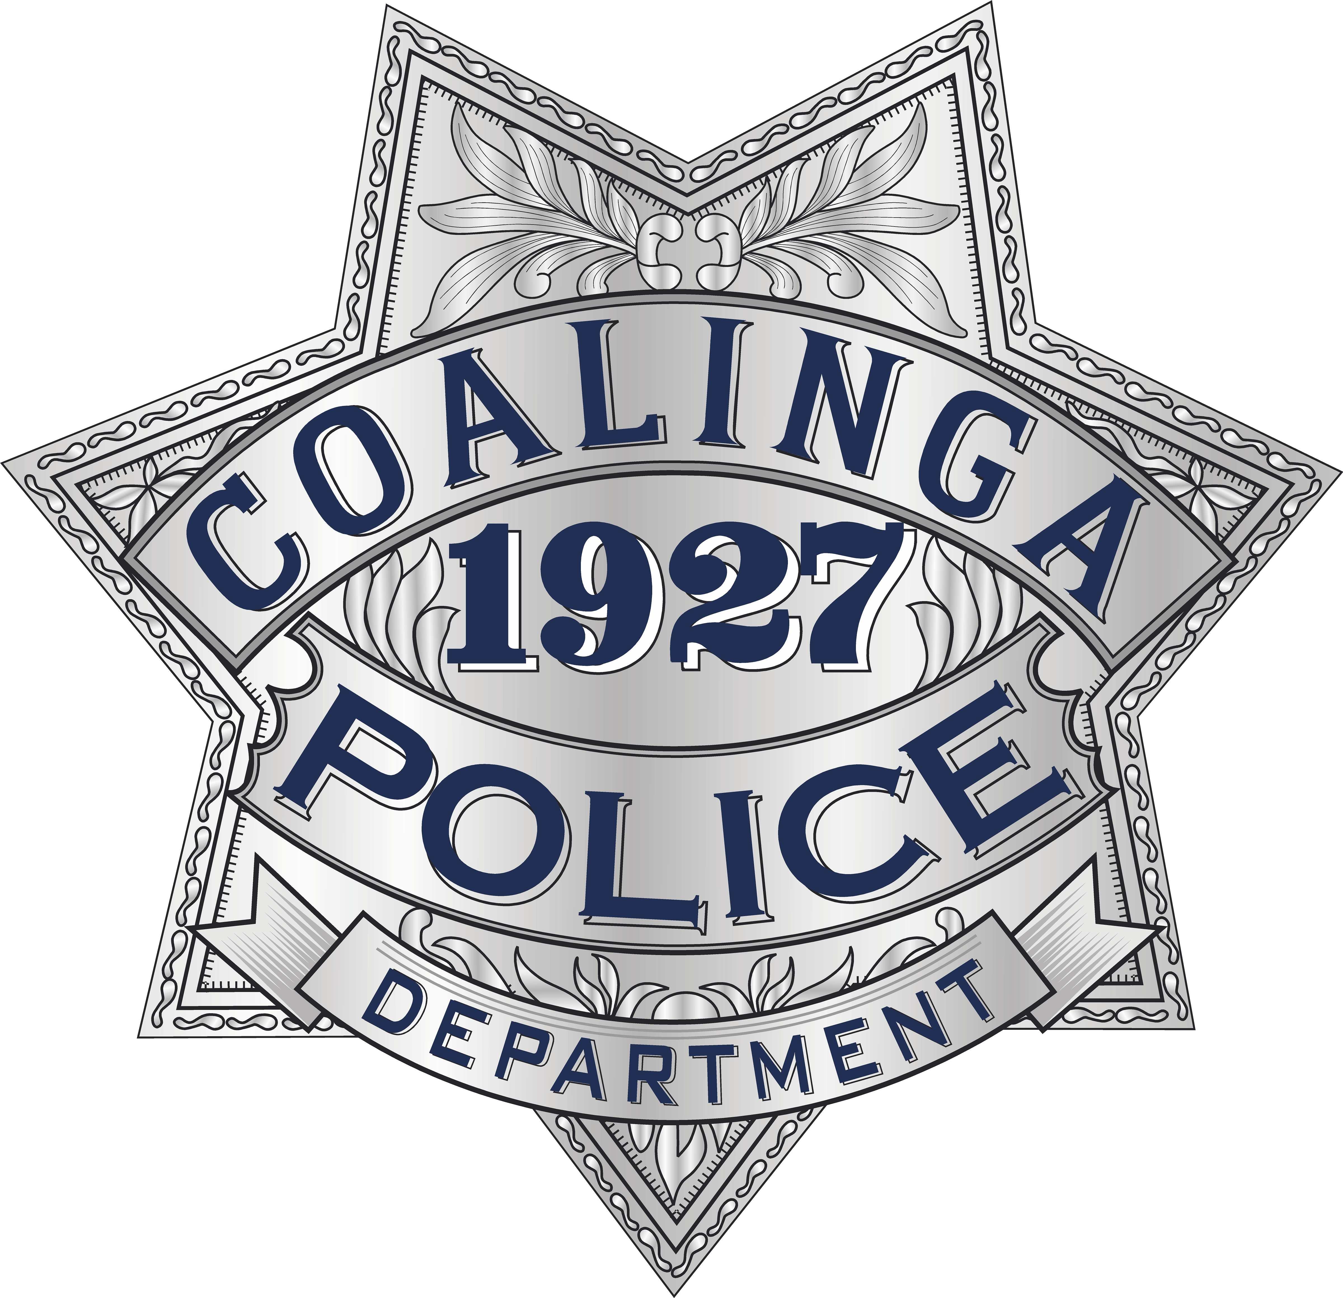 | City of Coalinga
 |  |  |  | Police Department
Darren Blevins, (I) Chief of Police |  |  |  |  | 270 N. Sixth St.  Coalinga, CA 93210  Phone: (559) 935-1525  Fax: (559) 935-1756  E-Mail: police@coalinga.com
PRESS RELEASE

For Immediate Release:

Date: March 11, 2019

Prepared By/Contact Person: Darren Blevins, (I) Chief of Police

DISTURBANCE LEADS TO AN ARREST FOR STOLEN FIREARM

On March 11, 2019, at around 1:30 am, officers from the Coalinga Police Department were dispatched to the local Fastrip gas station on the report of a disturbance. The reporting party stated there were several "Norteno" criminal street gang members outside the store provoking a fight with a possible rival "Bulldog" criminal street gang member.

As officer’s were responding to the area, they were given a description of the fleeing vehicle. Officer’s located this vehicle described as a white Chrysler 300, in the area of Cambridge and Hannah Street and conducted a traffic enforcement stop.

Officer contacted 18-year-old Coalinga resident, Rafael Vargas, 18-Year-old Coalinga resident, Alvaro Araujo and 22-year-old Lemoore resident Alexis Barrio inside the vehicle. All three occupants were confrontational and uncooperative with officers. Officer’s detained all three subjects and searched the vehicle, where they located a loaded black .380 semi-automatic hand gun that was determined to be stolen out of Coalinga last year.

All three occupants were arrested and later transported to the Fresno County Jail on charges of carrying a loaded firearm, possession of stolen firearm, carrying a loaded firearm inside a vehicle, carrying a loaded firearm while participating in a criminal street gang, felon in possession of a firearm, possession of ammunition, driving without a license and a misdemeanor bench warrant.

